**DAILY ONLINE ACTIVITIES SUMMARY**

|  |  |  |  |  |  |  |  |  |
| --- | --- | --- | --- | --- | --- | --- | --- | --- |
| **Date:** | **21-06-2020** | | | | | **Name:** | **Anix Jugal D’Cunha** | |
| **Sem & Sec** | **8 sem , A sec** | | | | | **USN:** | **4AL16CS013** | |
| **Online Test Summary** | | | | | | | | |
| **Subject** | | **No test was conducted** | | | | | | |
| **Max. Marks** | | **--** | | **Score** | | | **--** | |
| **Certification Course Summary** | | | | | | | | |
| **Course** | **Learn Basic HTML 5** | | | | | | | |
| **Certificate Provider** | | | **Udemy** | | **Duration** | | | **1.5 hours** |
| **Coding Challenges** | | | | | | | | |
| **Problem Statement:** Iterative python program to reverse an array | | | | | | | | |
| **Status: Competed** | | | | | | | | |
| **Uploaded the report in Github** | | | | | **yes** | | | |
| **If yes Repository name** | | | | | **alvas-education-foundation/dcunhaanixjugal** | | | |
| **Uploaded the report in slack** | | | | | **yes** | | | |

Online Test Details: (Attach the snapshot and briefly write the report for the same)

No test was conducted

Certification Course Details: (Attach the snapshot and briefly write the report for the same)

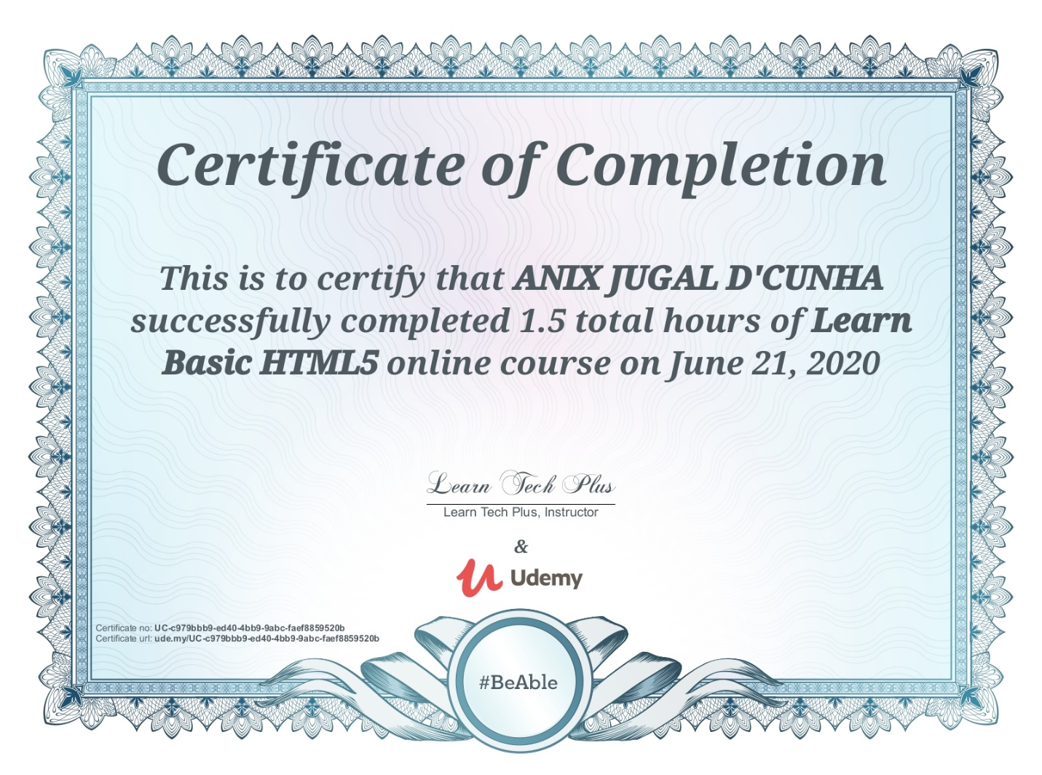

Coding Challenges Details: (Attach the snapshot and briefly write the report for the same)

Program->  Iterative python program to reverse an array

def reverseList(A,start,end):

while start<end:

A[start],A[end]=A[end],A[start]

start+=1

end-=1

A=[1,2,3,4,5,6]

print(A)

reverseList(A,0,5)

print("Reversedlistis")

print(A)